Artificial Intelligence (AI2002)
Date: May 27th 2024
Course Instructor(s)
Dr. Fahad Sherwani, Dr. Farrukh Hassan Syed, Mr. Syed Faisal Ali, Miss. Fizza Aqeel,
Miss. Mafaza Mohi, Mr. Sandesh Kumar

Final Exam
Total Time (Hrs): | 3
Total Marks: | 50
Total Questions: | 7

___________ __________ _____________________
Roll No Section Student Signature

Do not write below this line
Attempt all the questions.
CLO#1: To grasp the concepts of rational behavior and intelligent agents
Q1: Answer the following brief questions
- What are the primary characteristics that define a rational agent in Artificial Intelligence?
Answer: The primary characteristics that define a rational agent in artificial intelligence are: Goal-Oriented Behavior, Perception and Sensing, Decision-Making Ability, Action Execution, Adaptability and Learning, Performance Measurement, and Bounded Rationality
- Why CSPs use factored state representation? Give justification.
Answer: it effectively manages complexity and facilitates problem-solving in a structured and efficient manner. It provides modularity, scalability, incremental problem solving and etc.
- An autonomous drone delivery system operates in a complex environment where it must deliver packages to various locations within a city. Explain whether the environment for the agent is episodic or sequential. Justify your answer.
Answer: Episodic. Since each delivery is independent of the other, the environment should be considered episodic
- How does local beam search differ from standard hill-climbing algorithms in terms of handling multiple states simultaneously during search?
Answer: By managing multiple states, local beam search can explore the search space more thoroughly and is less likely to get trapped in local optima compared to the single-path approach of standard hill-climbing.
- What are the key differences between depth-first search (DFS) and breadth-first search (BFS) in terms of space and time complexity?
Answer: Both DFS and BFS have the same time complexity, their space complexity and traversal strategies differ significantly, making each suitable for different types of problems and graph structures.
- Assume that a rook can move on a chessboard any number of squares in a straight line, vertically or horizontally, but cannot jump over other pieces. Manhattan distance is an admissible heuristic for the problem of moving the rook from square A to square B in the smallest number of moves. Justify.
Answer: Since the Manhattan distance reflects the minimum travel required horizontally and vertically, and since the rook can cover any number of squares in these directions in a single move, the Manhattan distance never overestimates the actual cost. Therefore, it is an admissible heuristic for this problem.
- Minimax algorithm leads to outcomes at least as good as any other strategy only when the opponent is also optimal. Give Justification.
Answer: The Minimax algorithm leads to outcomes at least as good as any other strategy when the opponent is optimal because it is designed to handle the worst-case scenario with perfect rationality. While it guarantees the best outcome under optimal play, it may not always exploit suboptimal play as effectively as other adaptive strategies might.
- Write any two limitations of hill climbing algorithm in optimization problems
Answer: Local Optima and Plateaus and Ridges
- Given a CSP with n variables of domain size d, what would be the size of the search tree: (i) with commutativity (ii) Without commutativity.
Answer: With Commutativity: Exploiting commutativity fully theoretically reduces the number of unique nodes in the search tree, but this is not typically reflected in practical CSP algorithms. The combinatorial reduction is represented by $\left({n+d-1 \atop d-1}\right)$ though it's not a standard approach in typical search algorithms.
Without Commutativity: The search tree size is, $d^{n}$ representing all possible ordered assignments.
- Iterative deepening search can also be applied to adversarial search. Give Justification.
Answer: Iterative deepening search is well-suited for adversarial search because it combines the memory efficiency of depth-first search with the completeness of breadth-first search, handles time constraints effectively, benefits from improved move ordering, and integrates seamlessly with alpha-beta pruning to enhance search efficiency. [10 Marks]
Rubrics: 0.5 – Partial Attempt, 1 – Accurate Answer
CLO#3: To showcase comprehension and capability in implementing key concepts and methodologies in probabilistic reasoning, machine learning algorithms, and neural networks
Q2: (A). Consider a population in which 30% of individuals have a certain genetic trait, denoted as Trait A. Among those with Trait A, 70% also have Trait B, while among those without Trait A, 20% have Trait B.
- What is the conditional probability that an individual has Trait B given that they have Trait A?
Solution: $P\left(B | A\right)=70\%=0.7$
- What is the unconditional probability that a randomly selected individual from the population has Trait B?
Solution:
Given: $P\left(A\right)=30\%=0.3$
$P\left(-A\right)=1-P\left(A\right)=1-0.3=0.7$
$P\left(B | A\right)=0.7$
$P\left(B | -A\right)=0.2$
To find P(B), we use the law of total probability, which states
$$P\left(B\right)=P\left(B | A\right)P\left(A\right)+P\left(B | -A\right)P(-A)$$
$$P\left(B\right)=\left(0.7*0.3\right)+(0.2*0.7)$$
$$P\left(B\right)=\left(0.21\right)+(0.14)$$
$P\left(B\right)=0.35$

(B). Calculate the Joint Probability Distribution of the following figure 1.
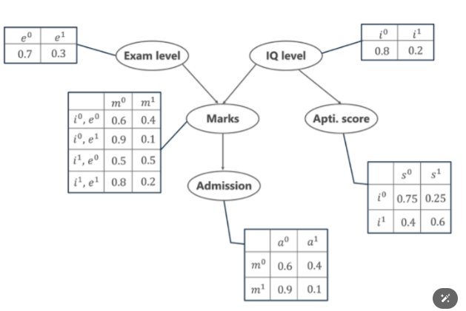
Figure 1: Bayesian Network
Solution:
Given Variables:
Exam Level (e), IQ level (i), Aptitude Score (s), Marks (m), Admission (a)
Formula: $P\left[a, m, i, e, s\right]=P\left(a | m\right).P\left(m | i,e\right).P\left(i\right).P\left(e\right).P(s|i)$
- Calculate the probability that in spite of the exam level being difficult, the student having a low IQ level and a low Aptitude Score, manages to pass the exam and secure admission to the university.
Solution:$P\left[a=1, m=1, i=0, e=1, s=0\right]=P\left(a=1 | m=1\right).P\left(m=1 | i=0,e=1\right).P\left(i=0\right).P\left(e=1\right).P(s=0|i=0)$
$$=0.1*0.1*0.8*0.3*0.75=0.0018$$

- In another case, calculate the probability that the student has a High IQ level and Aptitude Score, the exam being easy yet fails to pass and does not secure admission to the university.
Solution:$P\left[a=0, m=0, i=1, e=0, s=1\right]=P\left(a=0 | m=0\right).P\left(m=0 | i=1,e=0\right).P\left(i=1\right).P\left(e=0\right).P(s=1|i=1)$
$$=0.6*0.5*0.2*0.7*0.6=0.0252$$

[2+2+2 = 6 Marks]
Q3: (A). How does Naïve Bayes handle feature independence and missing data?
Solution: Naïve Bayes assumes that the features are conditionally independent given the class label. This means that the presence or absence of a particular feature is assumed to be unrelated to the presence or absence of any other feature, given the class label. One common approach for handling missing data in Naïve Bayes is to ignore the missing features during the calculation of the conditional probabilities.

(B). Build a Naïve Bayes Classifier for the given table 1 and use your model to classify the following table 2 as new instances.
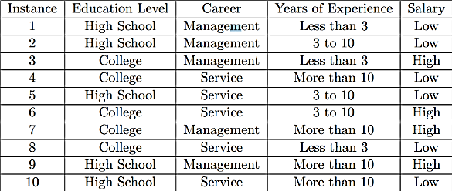
Table 1: Training Data
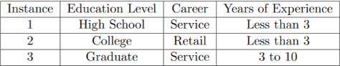
Table 2: Test Data
Solution:
Step1: Calculate Prior Probabilities
From Table 1: Total Instances: 10, Salary = Low:5, Salary = High:5
Prior Probabilities: $P\left(Low\right)=\frac{5}{10}=0.5$, $P\left(High\right)=\frac{5}{10}=0.5$

Step 2: Calculate Likelihoods
For Salary = Low
Education Level: High School: 3/5 = 0.6, College: 2/5 = 0.4, Graduate = 0/5 = 0 (not present)
Career: Management: 2/5 = 0.4, Service: 3/5 = 0.6, Retail: 0/5 = (not present)
Years of Experience: Less than 3: 2/5 = 0.4, 3 to 10: 2/5 = 0.4, More than 10: 1/5 = 0.2

For Salary = High
Education Level: High School: 1/5 = 0.2, College: 4/5 = 0.8, Graduate: 0/5 = 0 (not present)
Career: Management: 3/5 = 0.6, Service: 2/5 = 0.4, Retail: 0/5 = 0 (not present)
Years of Experience: Less than 3: 1/5 = 0.2, 3 to 10: 2/5 = 0.4, More than 10: 2/5 = 0.4

Step 3: Classify New Instances
Instance 1: High School, Service, Less than 3
For Low: $P\left(Low | Instance 1\right)∝P\left(Low\right) . P\left(High School | Low\right).P\left(Service | Low\right).P(Less than 3|Low)$
$$∝0.5 x 0.6 x 0.6 x 0.4=0.072$$
For High: $P\left(High | Instance 1\right)∝P\left(High\right) . P\left(High School | High\right).P\left(Service | High\right).P(Less than 3|High)$ $∝0.5 x 0.2 x 0.4 x 0.2=0.008$
Since 0.072 > 0.008 , classify as low

Instance 2: College, Retail, Less than 3
For Low: $P\left(Low | Instance 2\right)∝P\left(Low\right) . P\left(College | Low\right).P\left(Retail | Low\right).P(Less than 3|Low)$
$$∝0.5 x 0.4 x 0 x 0.4=0$$
For High: $P\left(High | Instance 2\right)∝P\left(High\right) . P\left(College | High\right).P\left(Retail | High\right).P(Less than 3|High)$ $∝0.5 x 0.8 x 0 x 0.2=0$
Both are 0 due to retail having 0 probability in both classes. Hence we’ll consider it undefined

Instance 3: Graduate, Service, 3 to 10
For Low: $P\left(Low | Instance 3\right)∝P\left(Low\right) . P\left(Graduate | Low\right).P\left(Service | Low\right).P(3 to 10|Low)$
$$∝0.5 x 0 x 0.6 x 0.4=0$$
For High: $P\left(High | Instance 3\right)∝P\left(High\right) . P\left(Graduate | High\right).P\left(Service | High\right).P(3 to 10|High)$ $∝0.5 x 0 x 0.4 x 0.4=0$
Both are 0 due to Graduate having 0 probability in both classes. Hence we’ll consider it undefined.

[2 + 4 = 6 Marks]
Q4: (A). List down two applications of regression and correlation.
Answer:
Regression: Predictive Analysis in Finance, Health Care
Correlation: Market Research, Environmental Studies
(B). The yield of a chemical process is a random variable whose value is considered to be a linear function of the temperature x. The following data in table 3 of corresponding values of x and y.

Temperature in Cº (x) | 0 | 25 | 50 | 75 | 100 | 125
Yield in Grams (y) | 10 | 25 | 40 | 55 | 70 | ?
Table 3: Training Data
Find the estimated yield in grams using regression, if the temperature is raised to 125 Cº
Solution: Solution is attached in file named as Q4 Part B Solution.
[1 + 3 = 4 Marks]
Q5: (A). You are a data analyst at a healthcare organization. Your task is to predict whether a patient is likely to have diabetes based on historical patient data. The dataset includes the following features for each patient:
- Age - BMI (Body Mass Index) - Blood Pressure - Insulin Level - Glucose Level
- Diabetes status (1 for diabetes, 0 for no diabetes)
Given the following data in table 4, use the K-Nearest Neighbors (KNN) algorithm to classify whether a new patient with the following characteristics will have diabetes, use k=3:
Age: | BMI: | Blood Pressure | Insulin Level | Glucose Level
45 | 28 | 80 | 100 | 140
Table 4: Test Data
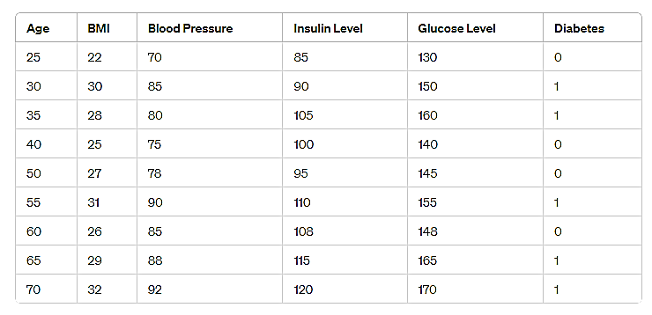
The historical data is in table 5 as follows:

Table 5: Training Data

Tasks:
1. Calculate the Euclidean distance between the new patient and all patients in the dataset.
2. Identify the K-nearest neighbors based on the distances calculated.
3. Predict whether the new patient will have diabetes using majority voting.
4. Discuss how the choice of k affects the classification result and how you might select an optimal k.

Solution:
Part 1: Identify the Features and the Target Variable
The features are:
- Age
- BMI
- Blood Pressure
- Insulin Level
- Glucose Level
The target variable is:
- Diabetes status

Part 2: Calculate the Euclidean Distance
Using the Euclidean distance formula:
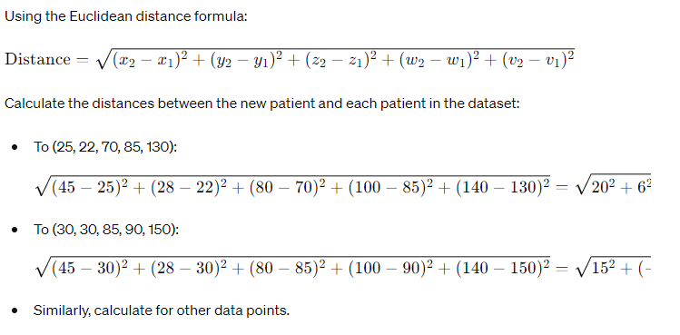

Part 3: Identify the K-Nearest Neighbors

Based on the calculated distances, identify the three nearest neighbors. The calculated distances are:
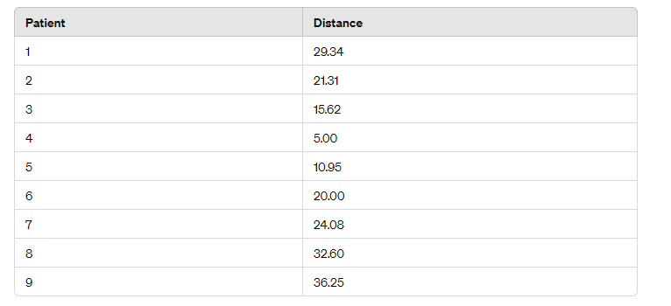

The three smallest distances are from patients 4, 5, and 2.

Part 4: Predict Using Majority Voting
Check the 'Diabetes' status of the 3 nearest neighbors:
- Patient 4: 0 (no diabetes)
- Patient 5: 0 (no diabetes)
- Patient 2: 1 (diabetes)
Since 2 out of 3 nearest neighbors do not have diabetes, the new patient is predicted to not have diabetes.
Final Prediction:
Thus, based on the K-Nearest Neighbors algorithm, the new patient is predicted not to have diabetes.

Part 5: Discussion on the choice of k and selecting an optimal k
- Impact of k on classification:
  - A smaller k (e.g., k=1) makes the classifier sensitive to noise, as it only considers the closest neighbor.
  - A larger k (e.g., k=10) smooths out noise but may include too many points from other classes, leading to potential misclassification.
  - An odd k is often chosen to avoid ties in binary classification problems.
- Selecting an optimal k:
  - Cross-validation: Split the dataset into training and validation sets multiple times and choose the k that minimizes the error rate on the validation sets.
  - Heuristics: Some heuristics suggest using √n​ where nnn is the number of data points.
  - Domain knowledge: Understanding the specific problem domain might guide the choice of k.

[1.5 + 1 + 1 + 0.5 = 4 Marks]
Q5: (B). Construct a complete decision tree using the ID3 algorithm on the provided data. Display the entire tree from the root node to leaf nodes as indicated in the set. Dataset of animal classification have the following attributes:
- Habitat (Forest, Desert, Grassland)
- Diet (Herbivore, Carnivore, Omnivore)
- Activity (Diurnal, Nocturnal)
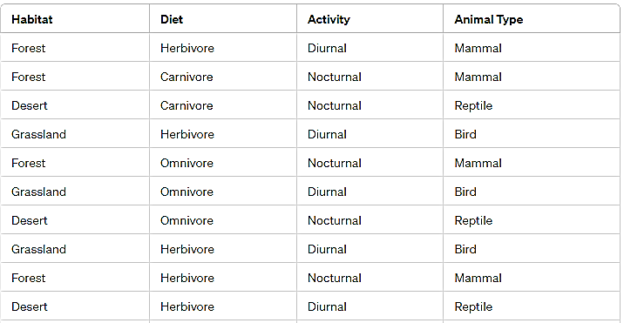
Animal Type (Mammal, Bird, Reptile) - this is the target variable. [8 Marks]

Table 6: Training Data

Solution: The difference I made in this question that I shrink the data up-till 10 rows, so student’s solution has minor diff of calculation that they place 10 in place of 14.

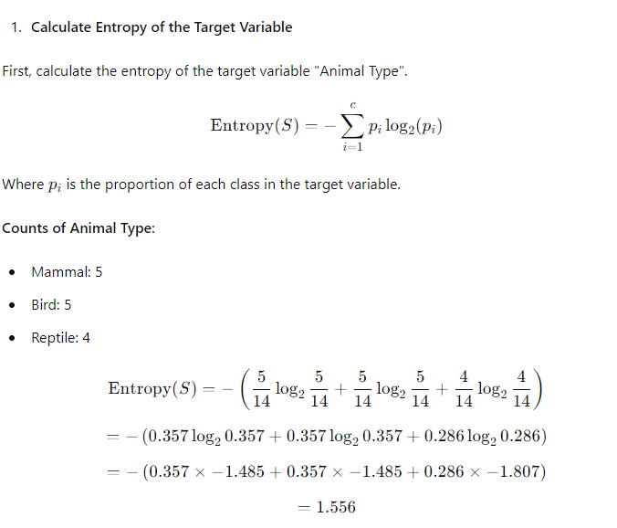

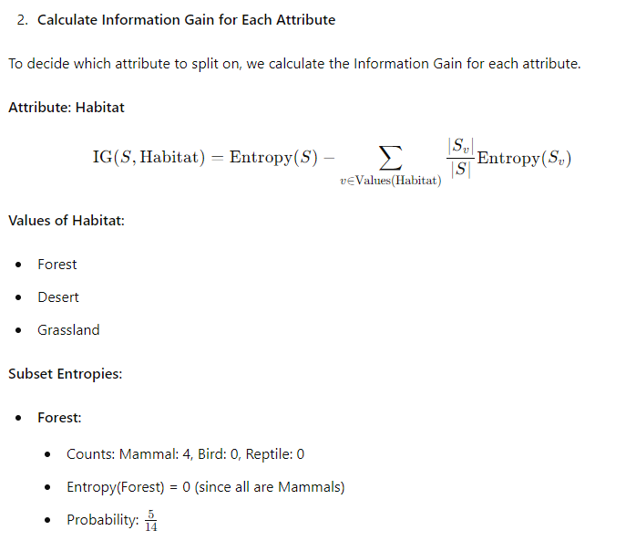
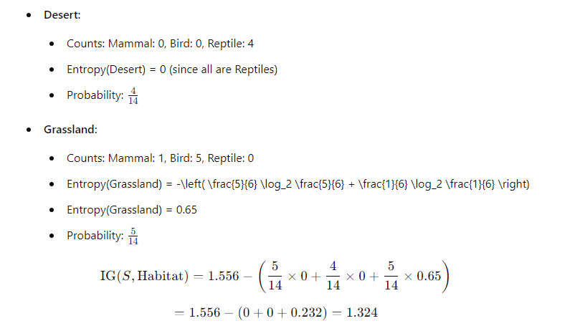
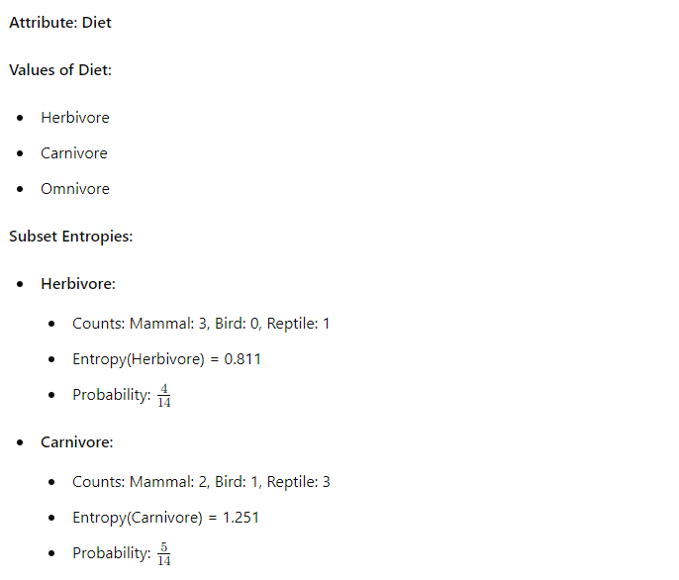
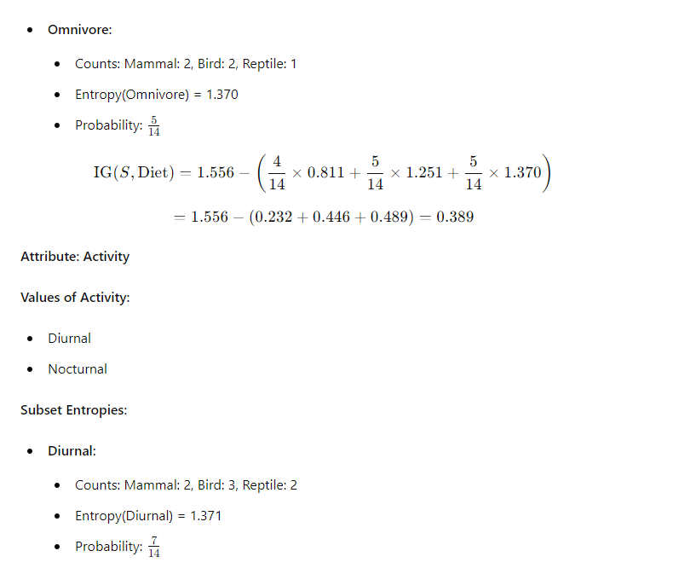
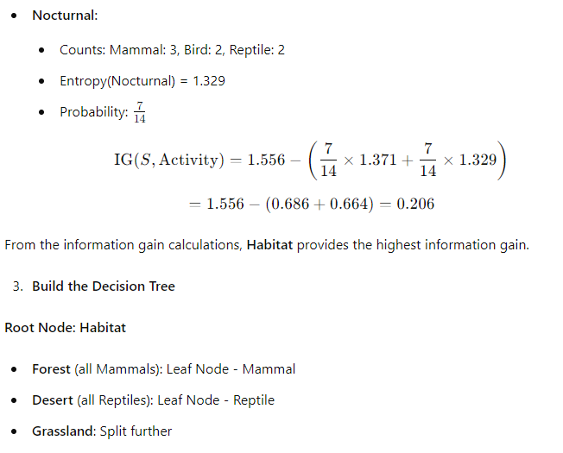
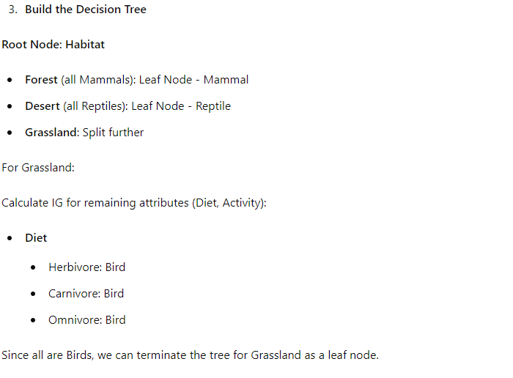
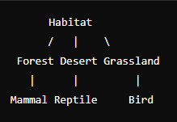

Q6: Use the k-means algorithm and Euclidean distance to cluster the following 8 examples into 3 clusters:
Data Points | A1 | A2 | A3 | A4 | A5 | A6 | A7 | A8
x | 2 | 2 | 8 | 5 | 7 | 6 | 1 | 4
Suppose that the initial seeds (centers of each cluster) are A1, A4 and A7. Initially, run the k-means algorithm for 2 epochs. After the 2nd epoch, please give the following:
- New Centroid Values
- Newly formed cluster sets.
- How many more iterations are needed to converge? Please Justify. [2+2+2= 6 Marks]
Solution:
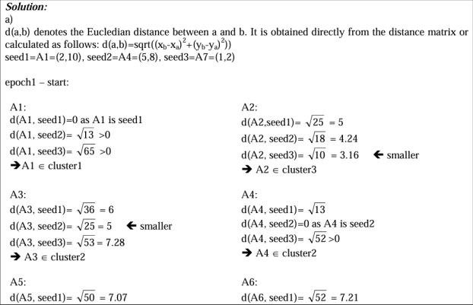
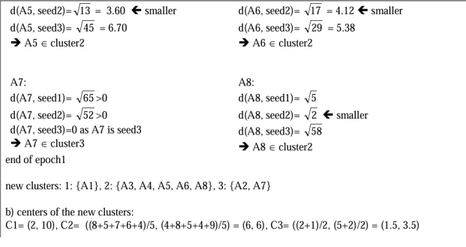
Note: 2nd iteration details are yet to be shown here, however the new clusters and their centers are mentioned in the details below.
At the end of 2nd epoch show: a) The new clusters (i.e. the examples belonging to each cluster)
After the 2nd epoch the results would be:
1: {A1, A8},
2: {A3, A4, A5, A6},
3: {A2, A7}
b) The centers of the new clusters After the 2nd epoch the new centers would be: centers C1=(3, 9.5), C2=(6.5, 5.25) and C3=(1.5, 3.5).
c) How many more iterations are needed to converge? We would need one more epoch for the points to converge. After the 3rd epoch, the results would be:
1: {A1, A4, A8},
2: {A3, A5, A6},
3: {A2, A7}
with centers C1=(3.66, 9), C2=(7, 4.33) and C3=(1.5, 3.5)

Q7: Consider a feedforward neural network with one input layer consisting of two input neurons, two hidden layers with three neurons each, and one output layer with one neuron. The activation function used in all layers is the sigmoid function. Draw the neural network and compute the output.

Input Layer to First Hidden Layer (Layer 1):  Neuron 1:  Weight 1: 0.1, Bias: -0.2  Weight 2: -0.3, Bias: 0.4  Neuron 2:  Weight 1: 0.5, Bias: -0.1  Weight 2: -0.2, Bias: 0.3  Neuron 3:  Weight 1: 0.4, Bias: 0.2  Weight 2: -0.1, Bias: -0.5 | First Hidden Layer to Second Hidden Layer (Layer 2):  Neuron 1:  Weight 1: 0.2, Bias: 0.1  Weight 2: -0.4, Bias: 0.3  Weight 3: 0.5, Bias: -0.2  Neuron 2:  Weight 1: 0.3, Bias: -0.4  Weight 2: -0.2, Bias: 0.2  Weight 3: 0.1, Bias: 0.3  Neuron 3:  Weight 1: -0.1, Bias: 0.2  Weight 2: 0.4, Bias: -0.3  Weight 3: -0.2, Bias: 0.1 | Second Hidden Layer to Output Layer (Layer 3):  Neuron 1:  Weight 1: -0.3, Bias: 0.5  Weight 2: 0.2, Bias: -0.1  Weight 3: 0.4, Bias: 0.3

Given an input vector [0.6, -0.1], calculate the output value of the neural network. Assume the sigmoid activation function for all neurons. [6 Marks]

Solution:

- Input Layer to First Hidden Layer (Layer 1):

For each neuron in the first hidden layer, we calculate the weighted sum of inputs and add the bias, then apply the sigmoid activation function.
Neuron 1: $z1(1)=(0.6*0.1)+(-0.1*-0.3)+(-0.2)=0.06+0.03-0.2=-0.11z1(1)=(0.6*0.1)+(-0.1*-0.3)+(-0.2)=0.06+0.03-0.2=-0.11 a1(1)=sigmoid(-0.11)≈0.472a1(1)=sigmoid(-0.11)≈0.472$
Neuron 2: $z2(1)=(0.6*0.5)+(-0.1*-0.2)+(-0.1)=0.3+0.02-0.1=0.22z2(1)=(0.6*0.5)+(-0.1*-0.2)+(-0.1)=0.3+0.02-0.1=0.22 a2(1)=sigmoid(0.22)≈0.554a2(1)=sigmoid(0.22)≈0.554$
Neuron 3: $z3\left(1\right)=\left(0.6*0.4\right)+\left(-0.1*-0.1\right)+\left(0.2\right)=0.24+0.01+0.2=0.45z3\left(1\right)= \left(0.6* 0.4\right)+\left(-0.1*-0.1\right)+\left(0.2\right)=0.24+0.01+0.2=0.45 a3\left(1\right)=sigmoid\left(0.45\right)≈ 0.611a3(1)=sigmoid(0.45)≈0.611$

- First Hidden Layer to Second Hidden Layer (Layer 2):
Similar to the previous step, we calculate the weighted sum of inputs plus the bias for each neuron in the second hidden layer and apply the sigmoid activation function.
Neuron 1: $z1\left(2\right)=\left(0.472*0.2\right)+\left(0.554*-0.4\right)+\left(0.611*0.5\right)+0.1=0.0944-0.2216+ 0.3055+0.1=0.2783z1\left(2\right)=\left(0.472*0.2\right)+\left(0.554*-0.4\right)+\left(0.611*0.5\right)+0.1=0.0944- 0.2216+0.3055+0.1=0.2783 a1\left(2\right)=sigmoid\left(0.2783\right)≈0.569a1\left(2\right)=sigmoid\left(0.2783\right)≈ 0.569$

Neuron 2: $z2\left(2\right)=\left(0.472*0.3\right)+\left(0.554*-0.2\right)+\left(0.611*0.1\right)-0.4=0.1416-0.1108+ 0.0611-0.4=-0.3071z2\left(2\right)=\left(0.472*0.3\right)+\left(0.554*-0.2\right)+\left(0.611*0.1\right)-0.4=0.1416- 0.1108+0.0611-0.4=-0.3071 a2\left(2\right)=sigmoid\left(-0.3071\right)≈0.423a2\left(2\right)= sigmoid(-0.3071)≈0.423$

Neuron 3: $z3\left(2\right)=\left(0.472*-0.1\right)+\left(0.554*0.4\right)+\left(0.611*-0.2\right)+0.2=-0.0472+0.2216- 0.1222+0.2=0.2522z3\left(2\right)=\left(0.472*-0.1\right)+\left(0.554*0.4\right)+\left(0.611*-0.2\right)+0.2=-0.0472+ 0.2216-0.1222+0.2=0.2522 a3\left(2\right)=sigmoid\left(0.2522\right)≈0.562a3\left(2\right)=sigmoid\left(0.2522\right)≈ 0.562$

- Second Hidden Layer to Output Layer (Layer 3):
Finally, for the output neuron, we calculate the weighted sum of inputs plus the bias and apply the sigmoid activation function.

$$z1(3)=(0.569*-0.3)+(0.423*0.2)+(0.562*0.4)+0.5=-0.1707+0.0846+0.2248+0.5=0.6387z1(3)=(0.569*-0.3)+(0.423*0.2)+(0.562*0.4)+0.5=-0.1707+0.0846+0.2248+0.5=0.6387 a1(3)=sigmoid(0.6387)≈0.654a1(3)=sigmoid(0.6387)≈0.654$$
So, the output value of the neural network for the given input vector [0.6,−0.1][0.6,−0.1] is approximately 0.654

